[**www.SanctusArt.com**](http://www.SanctusArt.com)

**Sanctus Catholic Art & Saints**

[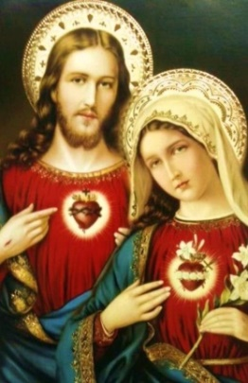](http://www.google.com/url?sa=i&rct=j&q=&esrc=s&source=images&cd=&cad=rja&uact=8&docid=I6wm3dy-l6FPbM&tbnid=9yebexl3n-rrwM:&ved=0CAUQjRw&url=http://www.pinterest.com/pin/22025485649938032/&ei=iPCuU7nZN4HyoATD44GIDA&bvm=bv.69837884,d.cGU&psig=AFQjCNFjSR7B4C5OOzz6hgWm7fqO7W2bYw&ust=1404060165710514)[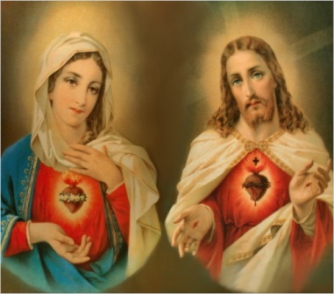](http://www.google.com/url?sa=i&rct=j&q=&esrc=s&source=images&cd=&cad=rja&uact=8&docid=P_Q8d79wdtzLLM&tbnid=EgibrOQu9--bZM:&ved=0CAUQjRw&url=http://www.catholictradition.org/save-souls.htm&ei=xu-uU6PgLYjhoAT63IHoDA&bvm=bv.69837884,d.cGU&psig=AFQjCNEShWUUUk55HOIaVymkVTp4UMTCkA&ust=1404059968423773)

**Prayer for Consecration: Sacred Heart of Jesus and Immaculate Heart of Mary**

Eternal Father, in the Holy Spirit I want to consecrate and commit myself to the Hearts of Jesus and Mary and to be a more devoted and faithful child.

Mother Mary, today I (name) commit myself to your Immaculate Heart. Keep me under your maternal protection and lead me to your Son Jesus.

Lord Jesus, through the Immaculate Heart of Mary, I consecrate and commit myself to your Sacred Heart. Mold my heart after your heart so that you will live in me ever more.

Sacred Heart of Jesus and Immaculate Heart of Mary, with this consecration and commitment I return to you the love you showed me in your earthly lives, especially on Calvary, and which you show me still today. At the same time I renew my baptismal consecration to the triune God: I renounce sin, temptation of evil and the devil; I believe in everything that God has revealed to us and which the Catholic Church teaches us.

I promise to fulfill Jesus' commandment of love for God and my neighbor, the commandments of God and of the Church and to act according to the doctrine of the Church under the successor of St. Peter. In this way I want to contribute to the unity and growth of the Church. I will personally pray the [rosary](javascript:na_open_window('win',%20'http://www.ourladyswarriors.org/prayer/15promise.htm',%200,%200,%20800,%20600,%201,%201,%201,%201,%201)) with my family and other communities and observe the devotion of the first Fridays and Saturdays, making reparation for my sins and the sins of all mankind.

O Sacred Heart of Jesus and Immaculate Heart of Mary, help me to accept the Gospel in my heart and to live it in faith, hope and love, that Jesus Christ will, through his cross and resurrection, become the way, the truth and the life for me. May I be nourished on heavenly bread and live out the sacrifice of the Eucharist so that I will overcome every evil and always choose life.

Full of trust I seek shelter in your loving hearts. Protect me in all dangers and after this earthly pilgrimage take me to my eternal home in Heaven. Amen. Sacred Heart