www.SanctusArt.com
Sanctus Catholic Art & Saints
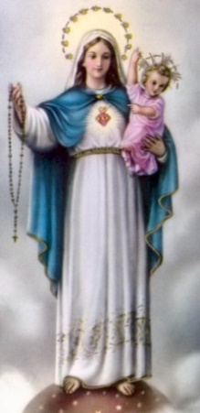
Our Lady of the Rosary
Feast Day: October 7
O Virgin Mary, grant that the recitation of thy Rosary may be for me each day, in the midst of my manifold duties, a bond of unity in my actions, a tribute of filial piety, a sweet refreshment, an encouragement to walk joyfully along the path of duty. Grant, above all, O Virgin Mary, that the study of thy fifteen mysteries may form in my soul, little by little, a luminous atmosphere, pure, strengthening, and fragrant, which may penetrate my understanding, my will, my heart, my memory, my imagination, my whole being. So shall I acquire the habit of praying while I work, without the aid of formal prayers, by interior acts of admiration and of supplication, or by aspirations of love. I ask this of thee, O Queen of the Holy Rosary, through Saint Dominic, thy son of predilection, the renowned preacher of thy mysteries, and the faithful imitator of thy virtues. Amen.

