www.SanctusArt.com
Sanctus Catholic Art & Saints
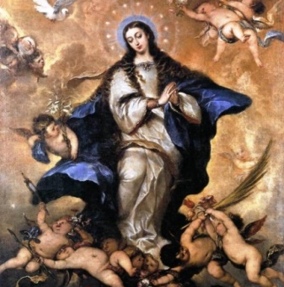
Our Lady of the Immaculate Conception
Feast Day: December 8th
Most holy Virgin, who wast pleasing to the Lord and became His Mother, immaculate in body and spirit, in faith and in love, look kindly on the wretched who implore thy powerful patronage. The wicked serpent, against whom was hurled the first curse, continues fiercely to attack and ensnare the unhappy children of Eve. Do thou, then, O Blessed Mother, our queen and advocate, who from the first instant of thy conception didst crush the head of the enemy, receive the prayers which, united with thee in our single heart, we implore thee to present at the throne of God, that we may never fall into the snares which are laid out for us, and may all arrive at the port of salvation; and, in so many dangers, may the Church and Christian society sing once again the hymn of deliverance and of victory and of peace. Amen.
In Thy conception, O Virgin Mary, thou wast immaculate; pray for us to the Father, Whose Son, Jesus Christ conceived of the Holy Ghost, thou didst bring forth.

