[**www.SanctusArt.com**](http://www.SanctusArt.com)

**Sanctus Catholic Art & Saints**

[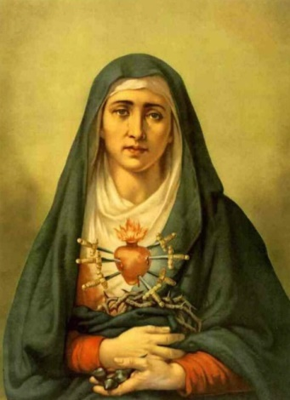](http://www.google.com/url?sa=i&rct=j&q=&esrc=s&frm=1&source=images&cd=&cad=rja&docid=uHGEUZgX5C5BGM&tbnid=pcwWYzuBASaICM:&ved=0CAUQjRw&url=http://veneremurcernui.wordpress.com/2012/09/06/novena-to-our-lady-of-sorrows/&ei=xPISUuy_IOGyyAGfvICQCQ&psig=AFQjCNEYVptPnHPwGq7M3N9i86aO_vzWIA&ust=1377059780154906)[](http://www.google.com/url?sa=i&rct=j&q=&esrc=s&source=images&cd=&cad=rja&uact=8&docid=IPwQ6b4qtZA6rM&tbnid=GBx_ibsSjFRR0M:&ved=0CAUQjRw&url=http://www.catholictradition.org/Mary/tears2.htm&ei=w-2uU6bMMYmBogS0moGoBg&bvm=bv.69837884,d.cGU&psig=AFQjCNHnoBJ-Z1wkUauTQjzMY-M5cU7R5g&ust=1404059274684264)

**Our Lady of Sorrows**

**Feast Day: September 15**

Hallowed Mother, do this favor: Those Wounds that gored my Savior, deeply on my heart engraved. Mine it be, Christ's throes in sharing. Mine it be, his anguish bearing. These, his wounds, to keep in mind. From the flame of hell unending, be thou, Virgin, me defending, in that dreadful reckoning day! When in death my eyes are closing, open them, Lord, to see reposing, Victory's crown in Mary's hand. When my frame by death is broken, and my doom by thee is spoken, be it, Lord, the better land.

Amen.

I beseech you, O Lord Jesus Christ, that the Blessed Virgin Mary, whose most holy soul was pierced in the hour of your Passion by the sword of sorrow, may intercede for us with Your mercy now and at the hour of our death.

Amen.