www.SanctusArt.com
Sanctus Catholic Art & Saints
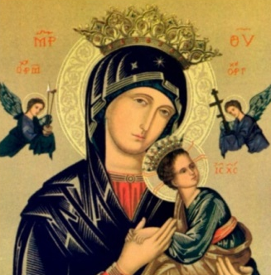
Our Lady of Perpetual Help
Feast Day: June 27
Mother of Perpetual Help, you have been blessed and favored by God. You became not only the Mother of the Redeemer, but the Mother of the redeemed as well. We come to you today as you loving children. Watch over us and take care of us. As you held the child Jesus in your loving arms, so take us in your arms. Be a mother ready at every moment to help us. For God who is mighty has done great things for you, and his mercy is from age to age on those who love him. Our greatest fear is that in time of temptation, we may fail to call out to you, and become lost children. Intercede for us, dear Mother, in obtaining pardon for our sins, love for Jesus, final perseverance, and the grace always to call upon you, Mother of Perpetual Help.
Amen.

