www.SanctusArt.com
Sanctus Catholic Art & Saints
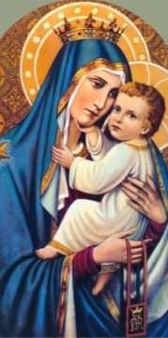
Our Lady of Mount Carmel
Feast Day: July 16
Thou who, with special mercy, look upon those clothed in thy beloved Habit, cast a glance of pity upon me. Fortify my weakness with thy strength; enlighten the darkness of my mind with thy wisdom; increase my faith, hope and charity. Assist me during life, console me by thy presence at my death, and present me to the August trinity as thy devoted child, that I may bless thee for all eternity in Paradise.
Amen.
.

