[**www.SanctusArt.com**](http://www.SanctusArt.com)

**Sanctus Catholic Art & Saints**

[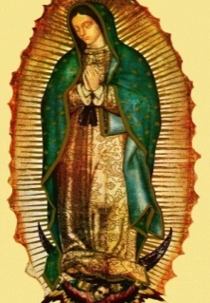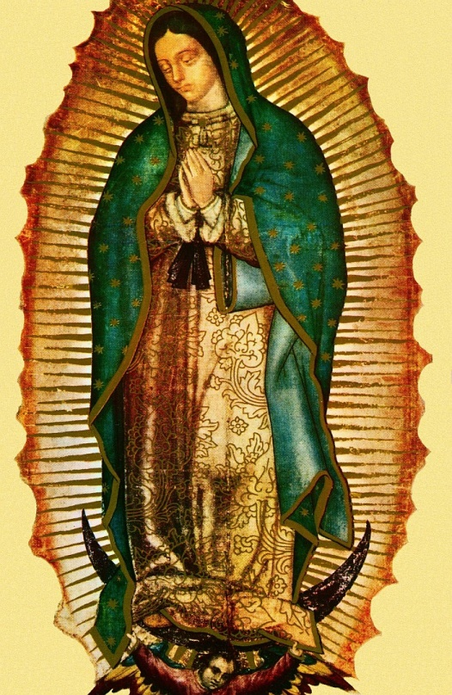](http://www.google.com/url?sa=i&rct=j&q=&esrc=s&frm=1&source=images&cd=&cad=rja&docid=n1CeizIMAH0yqM&tbnid=D0pdXMPcVebFLM:&ved=0CAUQjRw&url=http://stpiusxpress.com/?page_id=252&ei=h-LcUZPNJ-n-iwKIsYD4Cg&bvm=bv.48705608,d.cGE&psig=AFQjCNGOqGt2z3Tm2HIG9iK6Br7z5m9eEA&ust=1373515612768672)

**Our Lady of Guadalupe**

**Feast Day: December 12**

God of power and mercy, you blessed the Americas at Tepeyac with the presence of the Virgin Mary of Guadalupe. May her prayers help all men and women to accept each other as brothers and sisters. Through your justice present in our hearts may your peace reign in the world. We ask this through our Lord Jesus Christ, your Son, who lives and reigns with You and the Holy Spirit, one God, for ever and ever.

Amen.