www.SanctusArt.com
Sanctus Catholic Art & Saints
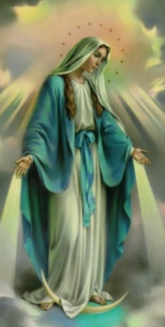
Our Lady of Grace
Feast Day: May 31

It becomes you to be mindful of us, as you stand near Him Who granted you all graces, for you are the Mother of God and our Queen. Help us for the sake of the King, the Lord God Master Who was born of you.
For this reason you are called "full of grace". Remember us, most holy Virgin and bestow on us gifts from the riches of your graces, Virgin, full of grace.
Amen

