www.SanctusArt.com
Sanctus Catholic Art & Saints
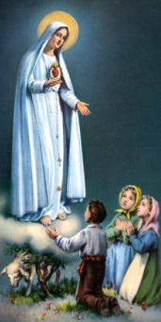
Our Lady of Fatima
Feast Day: May 3
O Most Holy Virgin Mary, Queen of the most holy Rosary, you were pleased to appear to the children of Fatima and reveal a glorious message. We implore you, inspire in our hearts a fervent love for the recitation of the Rosary. By meditating on the mysteries of the redemption that are recalled therein may we obtain the graces and virtues that we ask, through the merits of Jesus Christ, our Lord and Redeemer.
Amen.
.

