www.SanctusArt.com
Sanctus Catholic Art & Saints
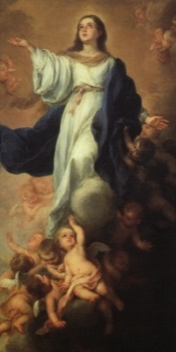
The Assumption of Mary
Feast Day: August 17
Father in heaven, all creation rightly gives you praise,
for all life and all holiness come from you. In the plan of your wisdom
she who bore the Christ in her womb was raised body and soul in glory to be with him in heaven. May we follow her example in reflecting your holiness
and join in her hymn of endless love and praise. We ask this through Christ our Lord.
Amen.

