[**www.SanctusArt.com**](http://www.SanctusArt.com)

**Sanctus Catholic Art & Saints**

[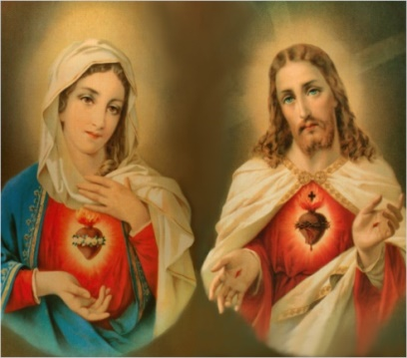](http://www.google.com/url?sa=i&rct=j&q=&esrc=s&source=images&cd=&cad=rja&uact=8&docid=P_Q8d79wdtzLLM&tbnid=EgibrOQu9--bZM:&ved=0CAUQjRw&url=http://www.catholictradition.org/save-souls.htm&ei=xu-uU6PgLYjhoAT63IHoDA&bvm=bv.69837884,d.cGU&psig=AFQjCNEShWUUUk55HOIaVymkVTp4UMTCkA&ust=1404059968423773)[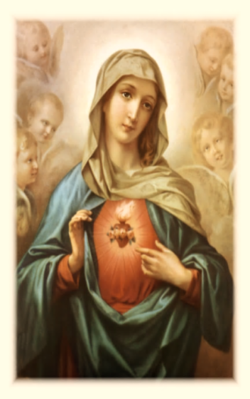](http://www.google.com/url?sa=i&rct=j&q=&esrc=s&frm=1&source=images&cd=&cad=rja&docid=g-CQ1cr15Wc9pM&tbnid=c9gN5wTL-0SAsM:&ved=0CAUQjRw&url=http://angelstarspeaks.me/novena-prayer-to-the-immaculate-heart-of-mary/&ei=0dQqUbmSOsHJiwLR6IGYCQ&psig=AFQjCNEusagXCLIlD_ndl0Lv6oDlkpdXXw&ust=1361847116237417)[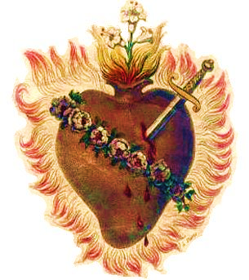](http://www.google.com/url?sa=i&rct=j&q=&esrc=s&frm=1&source=images&cd=&cad=rja&docid=lk__wYNVEiH5-M&tbnid=VEzUFY_DUZNfCM:&ved=0CAUQjRw&url=http://www.fisheaters.com/ih.html&ei=eYzhUY20FcqpigLklYGIDg&bvm=bv.48705608,d.cGE&psig=AFQjCNHM60QOBWCyvhClm6dVx38VCxfxUw&ust=1373822443677707)

**Immaculate Heart of Mary**

**Celebrated: Saturday after the Feast of the Sacred Heart of Jesus**

O Immaculate Heart of Mary, Heavenly beauty and splendor of the Father, You are the most valued Heavenly treasure.   
New Eve, immaculate in soul, [spirit](http://www.catholic.org/encyclopedia/view.php?id=11004) and body, created of the godly seed by the [Spirit](http://www.catholic.org/encyclopedia/view.php?id=11004) of God, You are the spiritual Mother of mankind.  
Pure Virgin, full of [grace](http://www.catholic.org/encyclopedia/view.php?id=5305) then and now, Your whole being was raised Heavenly in full glory, To be elevated above all the hosts within the Kingdom of God.  
O Heavenly Mother, Queen of [Heaven](http://www.catholic.org/encyclopedia/view.php?id=5593) and earth, I recognize the [glory](http://www.catholic.org/encyclopedia/view.php?id=5201) of your highest title, The Immaculate Heart of Mary!  
Loving Mother, dispenser of endless blessings, You who continuously intercedes on our behalf, Please present my need before your loving Son Jesus.  
(In your own words, make your special request here. Do not just mention a word. Speak to the Immaculate Heart of [Mary](http://www.catholic.org/bookstore/?category=19) as you would speak to another person, begging your Heavenly Mother to plea to [Jesus](http://www.catholic.org/clife/jesus) on your behalf, that you be granted this special request.)  
O Immaculate Heart of Mary, I know that you are now presenting my need before Jesus, For you have never turned away those in dire need.  
Mother dearest, I await your favorable answer, submitting myself to the Divine [will](http://www.catholic.org/encyclopedia/view.php?id=12332) of the Lord, For all glories are His forever and ever.

Amen

.