www.SanctusArt.com
Sanctus Catholic Art & Saints
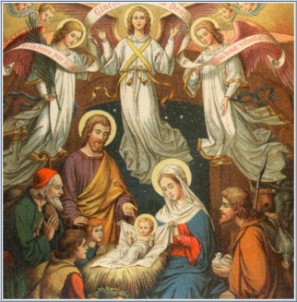
Nativity Prayer
December 25th
Let the just rejoice, for their justifier is born.
Let the sick and infirm rejoice, for their savior is born.
Let the captives rejoice, for their Redeemer is born.
Let slaves rejoice, for their Master is born.
Let free men rejoice, for their Liberator is born.
Let All Christians rejoice, for Jesus Christ is born.
St. Augustine of Hippo (AD 354-440)

